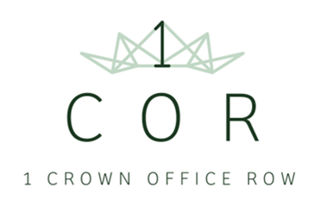
APPLICATION FORM FOR 1 CROWN OFFICE ROW
E&D ASSESSED MINI-PUPILLAGE SCHEME
Name:

Address:

Name and address of state school or college attended:

A levels or equivalent qualifications obtained:

Name of current/past university:

Please tick the boxes below which apply to you:
Neither of my parents went to university
I have received free school meals
My family has received income support
I have caring responsibilities
I was in care myself
Please add below any other relevant information about yourself or your circumstances that you would like to draw to our attention (please feel free to continue on another sheet of paper if you wish)

I confirm that the information in this form is true to the best of my knowledge and belief.
NAME (printed):
SIGNED:
DATE:

